**Station #1**

Learning Goal #1: Classify polynomials by identifying the standard form, leading coefficient, degree, and the number of terms

Learning Goal #2: Determine end behavior of polynomials

**(Use the Snowmen End Behavior Polynomials Practice)**

**Station #2**

Learning Goal #3: Use polynomial identities to multiply expressions

Learning Goal #4: Use polynomial identities to factor expressions

**Work on Polynomial Identities Practice!**

**Polynomial Identities & Factoring**

**Expand the product using polynomial identities. Show work!**

**1.**  2.

3. 4.

5.

**Factor each expression using the polynomial identities. Show work!**

6. 7.

8. 9.

10.

**Polynomial Identities Race**

Race against your partner/teammate using the set of problems provided. You can use any problem. Write the number of the problem you worked on and show your work. When your done after time is called, inform me if you would like to get smarties as a prize!

|  |  |
| --- | --- |
|  |  |
|  |  |
|  |  |
|  |  |
|  |  |
|  |  |
|  |  |
|  |  |
|  |  |
|  |  |

**Station #3**

Learning Goal #5: Use the Remainder Theorem to evaluate polynomials

Learning Goal #6: Determine whether a given binomial is a factor of a polynomial (using Remainder, Factor Theorem, and/or long division).

**Use the Remainder Theorem to find the remainder for each division. Determine if the binomial is a factor of the polynomial. DO NOT USE LONG DIVISION.**

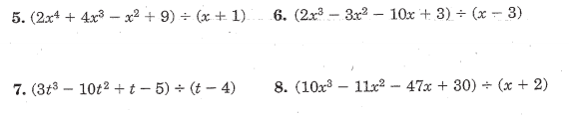

Learning Goal #7: Divide polynomials using long division

**Choose EITHER (a) color sheet by number or (b) maze activity to work on.**

**Station #4**

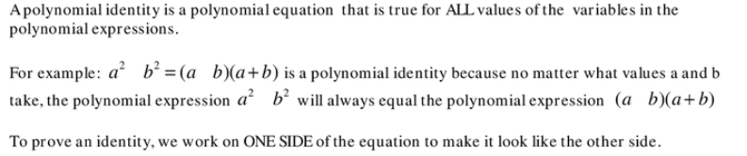

Example:

To prove, FOIL the right hand side:

Combine like terms on the right side:

Prove the following identities:

1.

2.

*3.

*4.