**Name: Date:**

**Topic: 5.1-Nth Roots, Radicals, and Rational Exponents (Class Notes)**

**Essential Question:**

Questions/Key Ideas Notes/Problems/Work

Powers & Roots

Rational Exponents

Example 1 Convert between radical and exponential form. Simplify. Find the value on the calculator if possible.

Questions/Key Ideas Notes/Problems/Work

Example 2 Convert between radical and exponential forms. Do not simplify.

1.  (b) 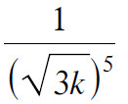

(c) 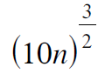 (d) 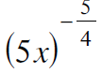

Simplify Radicals

Example 3 Simplify the following radical expressions. Use absolute values where appropriate.

(c)

Summary (Address EQ):