6.4: Exponential & Logarithmic Functions
Graphing Calculator Exercises
Use the TI-84+ calculator for the following exercises that require graphing.
1. Graph the function $y=2^{x}$  2. What is the inverse of $y=2^{x}?$ Graph this function.  $$f^{-1}\left(x\right)=$$  3. Provide a table of values for the inverse function.  X Y  1  2  4  8  16  4. Draw the line y = x. Are the two graphs symmetric about the line?  Yes No | 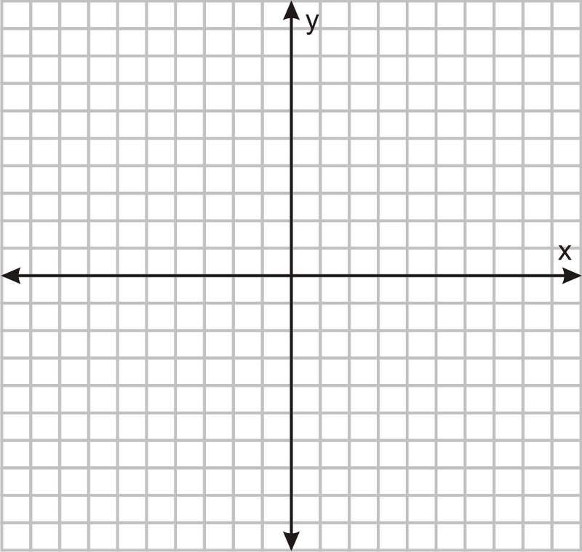
5. Graph the following function. Identify the domain and range. List any intercepts or asymptotes. Describe the end behavior.

$f\left(x\right)=\log_{8}{x}$

Domain:
Range:
x-intercept:
y-intercept:
Asymptote(s):
End behavior:

As $x→-∞, y→$________

As $x→∞, y →$ ________

6. Find the equation of the inverse of each function. Graph both functions

a. $f\left(x\right)=5^{x-3}$

b. $f\left(x\right)=\ln\left(x+3\right)-1$

