2.6 & 2.8 Assessment Review Key

1. Two real solutions

2. Two real solutions

3. One solution

4. Yes

5. x = 1, 5

6. x =

7. x =

8. Yes, the discriminant is about 0.8 and 0.8 > 0

9. (-4,1), (-2, 3)

10. (1,3), (-3,-1)

11. 39.5 ft

12. 2 solutions (graph below)

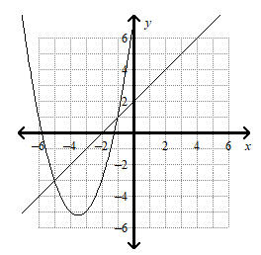

13. Two solutions (graph below):

