**Name: Date:**

**Topic: Adding and Subtracting Rational Expressions Day 2 (Class Notes)**

**Essential Question:**

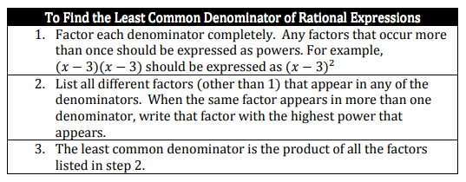 Questions/Key Ideas Notes/Problems/Work

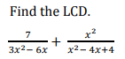

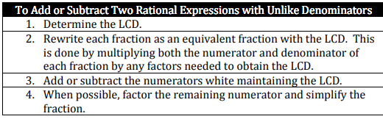





Questions/Key Ideas Notes/Problems/Work



Try It!





Summary (Address EQ):