1-2: Transformations Sheet f(x) = $a∙f\left(b\left(x-h\right)\right)+k$
|a| | Vertical Stretch:  Vertical Compression:  4f(x):  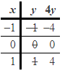 | If a > 1, then vertical stretch by factor of a  If 0 < a < 1, then vertical compression by factor of a  y-coordinates stay the same, affects the x-coordinates  Point notation:  (x, y) $→$ (x, ay) OR (x, f(x)) $→$(x, a$∙$f(x))
-a | Reflection across x-axis  -f(x):  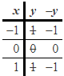 | x-coordinates stay the same, affects y-coordinates  (x, y) $→$ (x, -y) OR (x, f(x)) $→$ (x, -f(x))
|b| | Horizontal Stretch:  Horizontal Compression:  f(4x):  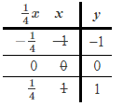 | If 0 < b < 1, then horizontal stretch by factor of 1/b  If b > 1, then horizontal compression by factor of 1/b  y-coordinates stay the same, affects the x-coordinates  (x, y) $→\left(\frac{1}{b}x, y\right)$ OR (x, f(x)) $→$ $\left(\frac{1}{b}x, f\left(bx\right)\right)$
-b | Reflection across y-axis  f(-x):  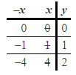 | y-coordinates stay the same, affects x-coordinates  (x, y) $→$ (-x, y) OR (x, f(x)) $→$(-x, f(-x))
h | Horizontal Translation  f(x-3):  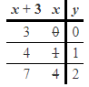 | y-coordinates stay the same, affects x-coordinates  f(x + h):  -graph moves left  -subtract h from the x-coordinates  (x, y) $→$ (x – h, y) OR (x, f(x)) $→$(x – h, f(x + h))  f(x – h):  -graph moves right  -add h to the x-coordinates  (x, y) $→$ $(x+h, y)$ OR (x, f(x)) $→$ (x + h, f(x – h))
k | Vertical Translation  f(x)-3:  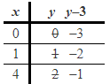 | x-coordinates stay the same, affects y-coordinates  f(x) + k:  -graph moves up  -add k to the y-coordinates  (x, y) $→$ (x, y + k) OR (x, f(x)) $→$ (x, f(x) + k)  f(x) – k:  -graphs moves down  -subtract k from the y-coordinates  (x, y) $→$ (x, y – k) OR (x, f(x)) $→$ (x, f(x) – k)

