**Ordered Pair Notation**

If k > 0 (positive), the graph shifts ___________________ (left, right)

If k < 0 (negative), the graph shifts ___________________ (left, right)

**Ordered Pair Notation**

If k > 0 (positive), the graph shifts _________________ (up/down)

If k < 0 (negative), the graph shifts _________________ (up/down)

**Questions**

**Vocabulary**

* Compression:
* Reflection:
* Stretch:
* Transformation:
* Translation:

**Translate a Function**

* A translation is a particular kind of ____________________ of a function, one that ______________ each point on a graph the same distance and direction.
* Other kinds of transformations may ____________ its graph across an axis, or ________________/compress its graph.
* In general, if g(x) = f(x) + k, then the graph of g is a _______________ translation of the graph of f by k units.
* In general, if g(x) = f(x-h), then the graph of g is a _____________ translation of the graph of f by h units.

**Name**: _______________________________ **Period**: ____ **Date**: _____________

**Topic**: Transformations of Functions

**Essential Question**: What do the differences between the equation of a function and the equation of its parent function tell you about the differences in the graphs of the two functions?

**I CAN…**

**Level 4**: Construct a real-world scenario, draw a graph, and write an equation based on the scenario.

Level 3: Apply transformations to graph functions and write equations.

Level 2: Understand key terminology as well as well as understand the basic processes of the lesson

Level 1: With help, I can understand key terminology and work with basic processes of the lesson

**Notes 1-2**

**p.1**

**p. 2**

**Example 1**

**A.** Graph the function for the domain [-2, 2]. The graph of g is the graph of f after a translation of 3 units down. How are the equations, domains, and ranges of f and g related?

Every point on the graph of **g** is ____ units below a corresponding point on the graph of **f**.

Notation:

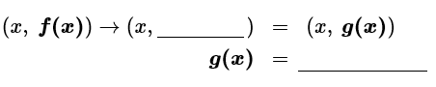

Graph:

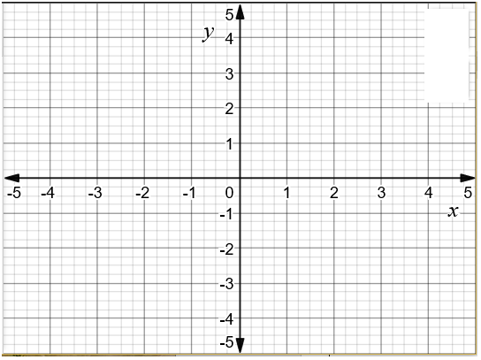

Domain and range:

The domains of f and g are both ___________. The range of f is __________, and the range of g is ___________.

**B.** Graph the function for the domain [-2, 2]. The graph of the function g is the graph of f after a translation 3 units to the right. How are the equations, domains, and ranges of f and g related?

Every point on the graph of **g** is ______ units to the ____________ of the corresponding point on the graph of **f**.

Notation:



Graph:



**Questions**

**p. 3**

Domain and range:

The translation of the graph of f to the graph of g can be described as ______________ = f(x), or g(x) = ________________

The range of f and g are both ___________. The domain of f is ____________, and the domain of g is _______________.

**Try It!**

**1**. **a.** How did the transformation of f to g in part (a) affect the intercepts?

**b**. How did the transformation of f to g in part (b) affect the intercepts?

**Reflect a Function Across the x- or y-Axis**

* A reflection maps each point to a new point across a given line, called the _________ of ________________. This line is the perpendicular bisector of the segment between the point and its ___________.

**Example 2**

**A.** Graph f(x) = 2x-6 and the function g, whose graph is the reflection of the graph of f across the x-axis. How are their equations related?

Graph f. Then graph g by reflecting each point of the graph of f across the x-axis. For each point (x,y) on the graph of f, plot the point (______, ________) to get the graph of g. Since the y-values of the new function have the opposite sign, g(x) = ____________.

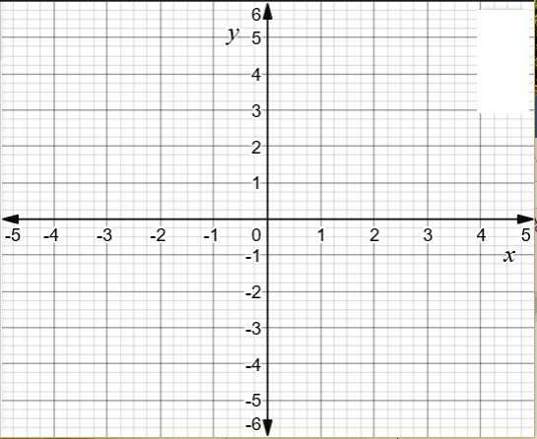

Y-intercept of f(x): y = _____ Slope of graph of f(x): m = _____

Y-intercept of g(x): y = _____ Slope of graph of g(x): m = _____

**Questions**

**Reflection about Y-axis Ordered Pair Notation**

**Reflection about X-axis Ordered Pair Notation**

**p. 4**

**Questions**

Equation of g: g(x) = _______________

**B.** Graph f(x) = 2x-6 and the function h, whose graph is the reflection of the graph of f across the y-axis. How are their equations related?

Graph f. Then reflect every point on the graph of f over the y-axis to produce the graph of h.



For any point (x, Y) on the graph of f, there is a reflected point ( ______, _______) on the graph of h, so h(x) = f(______).

X-intercept of h: x = _______ X-intercept of f: x = _________

Slope of f: m = ________ Slope of h: m = ________

The function h has a slope that is the ____________ of the slope of f but with the same _____-intercept.

**Try It!**

**2.** What is an equation for the reflected graph? Check by graphing.

**a.**  the graph of reflected across the x-axis



**p. 5**

**Questions**

**b.** the graph of reflected across the y-axis



**Understand Stretches and Compressions**

* A stretch is a transformation that ________________ the distance between the points of a graph and a given line by the same factor.
* A compression is a transformation that ______________ the distance between the points of a graph and a given line by the same factor.

**Example 3**

**A.** Graph f(x) = |x| with domain [-4, 4] and g(x) = 2 f(x). How are the domains and ranges related?

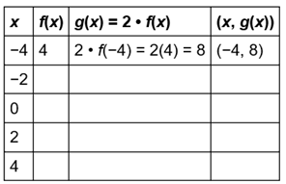

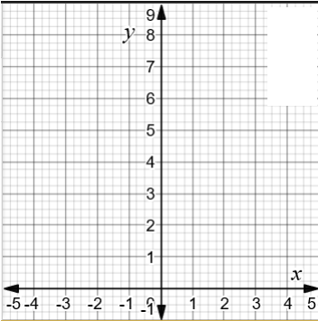

Domain of f(x): _________ Range of f(x): ___________

Domain of g(x): _________ Range of g(x): ___________

Transformation: The graph of g is a ____________ stretch of the graph of f by a factor of _____

**p. 6**

**Questions**

**B.** Graph f(x) = |x| with domain [-4,4] and h(x) = f(2x). How are the domains and ranges related?

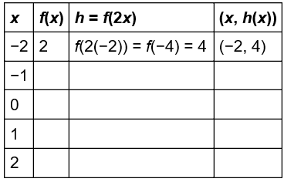



Range of f(x): ___________ Domain of f(x): ____________

Range of h(x): __________ Domain of h(x): ____________

Transformation: The graph of h is a ______________ compression of the graph of f by a factor of ______

**Try It!**

**3.** Show that j(x) = f() is a horizontal stretch of the graph of f.

**P. 7**

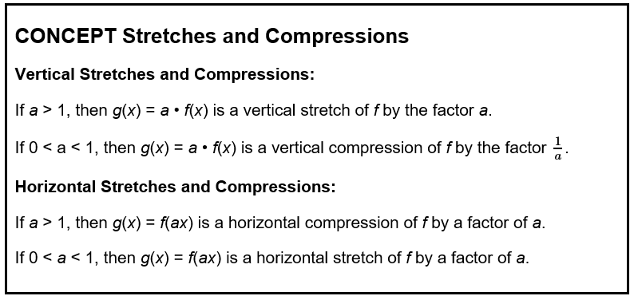

**Graph Combination of Transformations**

**Example 4**

The graph represents y = f(x). Using y = f(x), how can you graph a combination of transformations?

**A.** Graph y = -f(x+2). Describe both transformations.

Transformations:

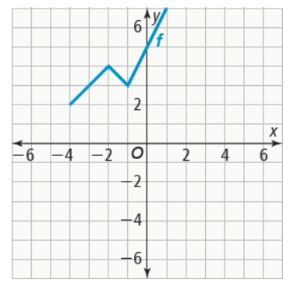

**B.** Graph y = f(x) + 3. Describe both transformations.

Transformations:



**Questions**

**Try It!**

**4.** Using the graph of f above, graph each equation.

**a.** y = f(2x) – 4



**b.** y = f(2x-3) – 2



**Identify Transformations From an Equation**

**Example 5**

What transformation of result in the graph of the function g?

**A**. **B.**

Transformations: Transformations:

**Try It!**

**5.** What transformations of the graph of f(x) = |x| are applied to graph the function g?

**a.**  g(x) = **b.**

Transformations: Transformations:

**Questions**

**P. 8**

**Write an Equation From a Graph**

A scenic train ride mades trips on an old mining line. The graph shows the distance y in kilometers of the train from the station x minutes after the ride begins. What equation represents the distance from the station as a function of time? What is its domain?

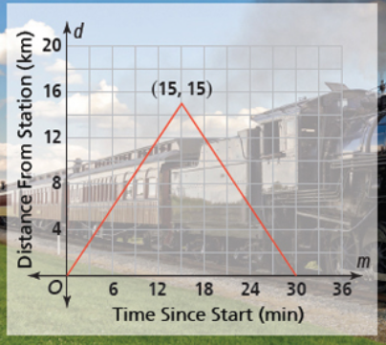

Type of graph: _________________ value

General form of function: y = _____________________

Show work to substitute point of vertex (15, 15) and solve for a using the point (0,0):

Equation for distance as a function of time: y = ____________________

Domain: ____________

**Try It!**

**6.** How would the graph and equation be affected if the train traveled twice as far in the same amount of time?

**Questions**

**Questions**

**Concept Summary Transformation of Functions**

General Form of Function: **f(x) =**

Use the function **f(x) =**

|  |  |  |
| --- | --- | --- |
| **WORDS** | **EQUATIONS** | **GRAPHS** |
| **Horizontal translation of f right 2 units** | f(x) becomes g(x) = _______________  **g(x) =** |  |
| **Vertical translation of f up 3 units** | f(x) becomes h(x) = _______________  **h(x) =** |
| **Reflection of f across the x-axis** | f(x) becomes _______  **-f(x) =** |  |
| **Reflection of f across the y-axis** | f(x) becomes _____________  **f(-x) =** |
| **Horizontal stretch of f by a factor of 2** | f(x) becomes ______________  **f() =** |  |
| **Vertical stretch of f by a factor of 2** | f(x) becomes ________  **2f(x) =** |

**Written Summary:**

**EQ:** What do the differences between the equation of a function and the equation of its parent function tell you about the differences in the graphs of the two functions?