**Questions/Work**

**Vocabulary**

* Piecewise-defined function:
* Step function:

**Model With a Piecewise-Defined Function**

* A piece-wise defined function has different rules for different parts of its _____________
* A curly bracket { notation is used for piecewise-defined functions to indicate the different _________________ at different parts of the ________________.

**Example 1**

Alani has a summer job as a lifeguard. She makes $8/h for up to 40 h each week. If she works more than 40 h, she makes 1.5 times her hourly pay, or $12/h, for each hour over 40 h. How could you make a graph and write a function that shows Alani’s weekly earnings based on the number of hours she worked?

Table of values and graph:

|  |  |  |  |  |  |  |  |  |  |  |  |  |  |  |  |  |  |  |  |
| --- | --- | --- | --- | --- | --- | --- | --- | --- | --- | --- | --- | --- | --- | --- | --- | --- | --- | --- | --- |
| |  |  | | --- | --- | | **Hours Worked** | **Pay** | | 20 | 160 | | 25 | 200 | | 30 |  | | 35 |  | | 40 |  | | 45 | 380 | | 50 | 440 | | 55 |  | |  |

**Name**: _______________________________ **Period**: ____ **Date**: _____________

**Topic**: Piecewise-Defined Functions

**Essential Question**: What do the differences between the equation of a function and the equation of its parent function tell you about the differences in the graphs of the two functions?

**I CAN…**

**Level 4**: Construct a real-world scenario, draw a graph, and interpret piecewise-defined function based on the scenario.

Level 3: Graph and interpret piecewise-defined function

Level 2: Understand key terminology as well as well as understand the basic processes of the lesson

Level 1: With help, I can understand key terminology and work with basic processes of the lesson

**Notes 1-3**

**p.1**

**Note:** A bar underneath the inequality means you have a filled (“closed) point  when you graph. No bar underneath the inequality means you have an open point 

**Note**: You can find Alani’s pay for x > 40 in a few ways, one of which is to use the point-slope form of a line from Algebra 1: . You can choose any point you’d like. We will choose (40, 320) from our table. Since Alani gets paid $12/h, this is the slope m = 12. Substituting this gives us y – 320 = 12(x – 40), which simplifies to the answer we get above.

**p. 2**

When , Alani’s pay is $8/h times the number of hours worked, so P(x) = ___________

When x > 40, Alani’s pay is P(x) = ________________________

Piecewise-defined function:

**Try It!**

**1.** How much will Alani earn if she works:

**a.** 37 hours? **b.** 43 hours?

**Graphing a Piecewise-Defined Function**

**Example 2**

|  |  |
| --- | --- |
| Graph the following function. What are the domain and range? Over what intervals is the function increasing or decreasing? |  |

|  |  |
| --- | --- |
| **Graph** | To determine the range, calculate the y-values that correspond to the _____________ and _________________  x-values on the graph.  Evaluate y = 4x + 11 for x = -10  y = ________________  y = _______  Evaluate y = x + 1 for x = 10  y = __________  y = _______  The domain is ____________________  Range is ______________________  Function is increasing when ______________ and ________________  The function is decreasing when ____________________ |

**Questions/Work**

**Try It!**

**2.** Graph the piecewise-defined function. What are the domain and range/ Over what intervals is the function increasing or decreasing?

|  |  |
| --- | --- |
|  |  |
|  |  |
| Domain:  Range:  Increasing:  Decreasing: | Domain:  Range:  Increasing:  Decreasing: |

**Write a Piecewise-Defined Rule From a Graph**

**Example 3**

|  |  |
| --- | --- |
| What is the rule that describes the piecewise-defined function shown in the graph? |  |

**Step 1** How many separate pieces of the function are there? _________

**Step 2** Determine the ________________ of each segment.

**Step 3** For each segment, use the graph to locate ______________ on the line and to find _____________

**Step 4** You can use the _____________-_________________ form of a line, f(x) = mx + b, to define the function for each segment.

**p. 3**

**Questions/Work**

**p. 4**

**Questions/Work**

|  |  |  |
| --- | --- | --- |
| **Segment A** | **Segment B** | **Segment C** |
| **Domain:** _______________ | **Domain:**  _________________ | **Domain:**  ___________________ |
| (1, -1); slope = _________ | (1, 4); slope = __________ | (5,8), slope = ___________ |
| y = mx + b | y = mx + b | y = mx + b |
| **f(x) = 3x -4** | **f(x) = x + 3** | **f(x) = 8** |

Rule:

**Try It!**

**3.** What rule defines the function in each of the following graphs?

|  |  |
| --- | --- |
|  |  |

Rule: Rule:

**Write a Rule for an Absolute Value Function**

**Example 4**

How can you rewrite the function f(x) = |6x + 18| as a piecewise-defined function?

**Step 1** Write the function in the form f(x) = ______________________ to find the vertex of the function.

Work:

Vertex: __________

How many pieces? ___________

Domain of piece 1: x < ______ Domain of piece 2: x > ________

**Note:** The parent absolute value function f(x) = |x| is a piecewise-defined function:

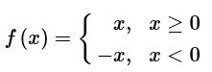

**p. 5**

**Questions**

|  |  |  |
| --- | --- | --- |
|  | **Choose a point so that x < -3: let x = -4** | **Choose a point so that x > -3: let x = 0** |
| **Point** | (-4, _______) | (0, _______) |
| **Slope to (-3, 0)** |  |  |
| **Equation** |  |  |

**Step 3** Write the piecewise-defined function.

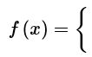

**Try It!**

**4.** How can you rewrite each function as a piecewise-defined function?

**a.** f(x) = |5x – 10| **b.** f(x) = |x| + 3

**Graphing Step Functions**

* A step function has a graph looks like the a _____________________.

**Example 5**

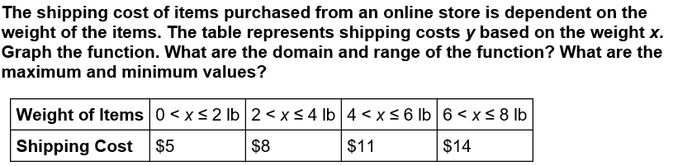

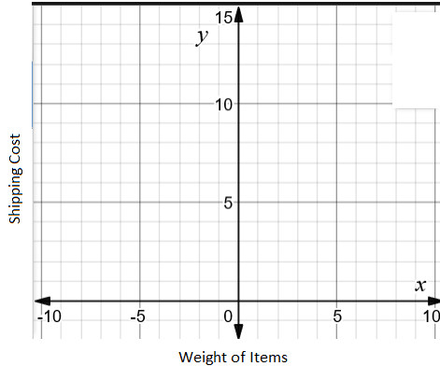

**p. 6**

**Questions**

Domain: ________________ Minimum: ____________

Range: _________________ Maximum: ____________

**Try It!**

**5.** The table below represents fees for a parking lot. Graph the function. What are the domain and range of the function? What are the maximum and minimum values?

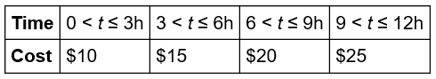

|  |  |
| --- | --- |
|  | Domain:  Range:  Maximum:  Minimum: |

**Concept Summary**

|  |  |  |
| --- | --- | --- |
| **WORDS** | **ALGEBRA** | **GRAPH** |
|  |  |  |

**Written Summary**

**EQ**: What do the differences between the equation of a function and the equation of its parent function tell you about the differences in the graphs of the two functions?

**P. 7**

**Questions**

**Questions**

**P. 8**

**Questions**

**Questions**