Directions to Installing Microsoft Office Software (Free)

1) Go to o365.com

2) Click on Sign in on upper right hand corner

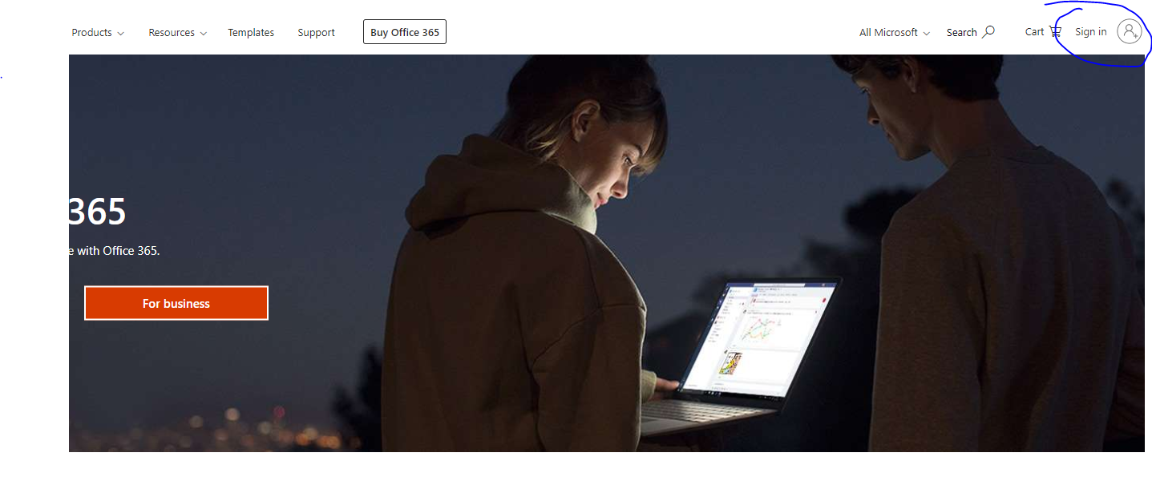

3) Your email is [R2.D2@pcsb.org](mailto:R2.D2@pcsb.org)

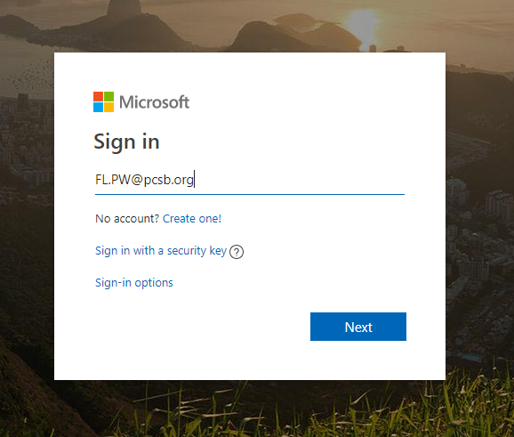

4) Your password is your usual password for Focus

5) Once you’re logged in, you will be taken back to the homepage. Click on your name or username, then click on For home.

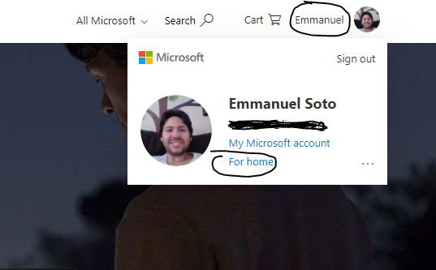

6) Click Install Office

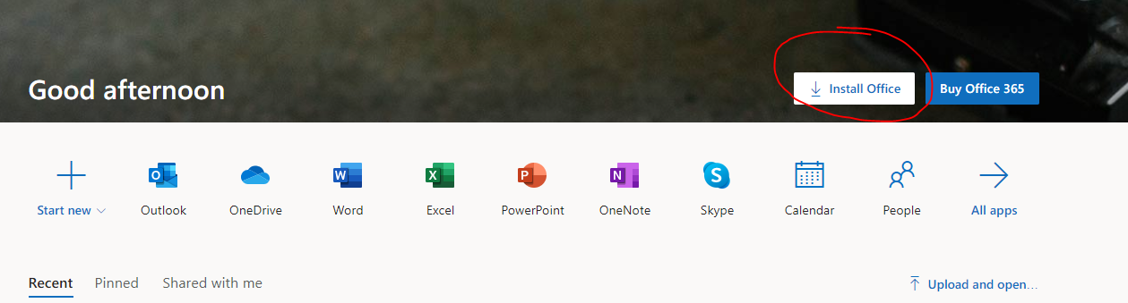

Note: You can install on up to 5 PCs or Macs for free!

7) If this doesn’t work, click on My Account (above the For home button). It will take you to your account information page. Then click Install Office. (shown below on next page)

