**Questions**

**Vocabulary**

* Average rate of change:
* Interval notation:
* Maximum:
* Minimum:
* Set-builder notation:
* Zero of a function:

**Domain and Range**

* The set of all possible inputs for a relation is called the ________________
* The set of all possible outputs for a relation is called the _______________
* A graph is called a function if each input has exactly one _______________
* There are two notations used to represent intervals of numbers like domain and range
* Set-Builder Notation uses a verbal description or an ________________ to describe the numbers.
  + i.e: {x |x is a real number} is read “__________________________________________________________”
* Interval notation represents a set of real numbers by the pair of values that are its left (_____________) and right (_________________) boundaries.

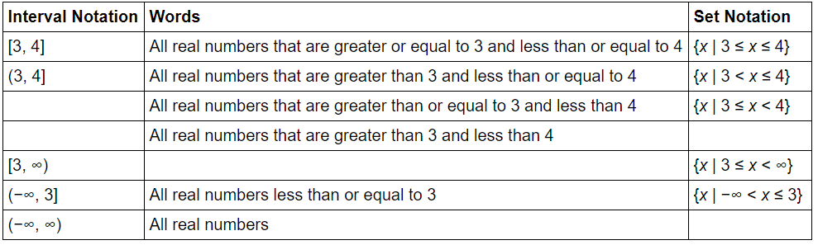

**Name**: _______________________________ **Period**: ____ **Date**: _____________

**Topic**: Key Features of Functions

**Essential Question**: How do graphs and equations reveal information about a relationship between two quantities?

**I CAN…**

**Level 4**: Construct a real-world scenario which demonstrates and models key features of linear, quadratic, and absolute value functions.

Level 3: Interpret key features of liner, quadratic, and absolute value functions given an equation or a graph

Level 2: Understand key terminology as well as well as understand the basic processes of the lesson

Level 1: With help, I can understand key terminology and work with basic processes of the lesson

**Notes 1-1**

**p.1**

**p. 2**

**Questions**

**Example 1**

**A.** What are the domain and range of the function defined by

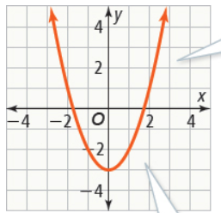

**B.** An airtanker flies over forest fires and drops water at a constant rate of 400 gal/s until its tank is empty. Its tank holds 8,000 gallons. What are the domain and range of the function that represents the volume of water the airtanker can drop in x seconds?

**Function:** _______________________

**Set-Builder Notation** **Interval Notations**

Domain:

Range:

**Try It!**

**1.** What are the domain and range of each function? Write the domain and range in set-builder notation and interval notation.

**a.** **b.**

**X- and Y-Intercepts**

* A y-intercept is the y-coordinate of a point where a graph intersects the _________________
* An x-intercept is the x-coordinate of a point where a graph intersects the x-axis

**Example 2**

**A.** A car starts a journey with a full tank of gas. The equation y = 16-0.05x relates the number of gallons of gas, y, left in the tank to the number of miles the car ha traveled, x. What are the x- and y-intercepts of the graph of this equation, and what do they represent about the situation?

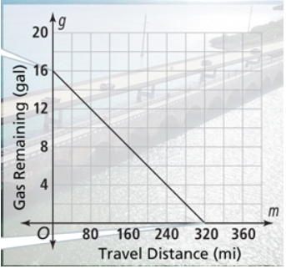

**p. 3**

* The x-intercepts are also the zeros of the function because they are the input values that result in a function output value of _________.

**B.** What are the x- and y-intercepts of the graph of y = |x| - 3?

**Try It!**

**2.** What are the x- and y-intercepts of

**Positive or Negative Intervals**

**Example 3**

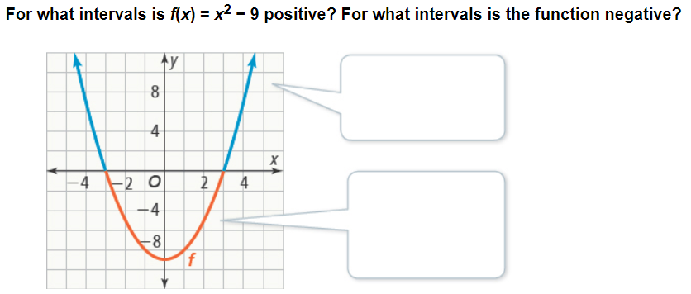

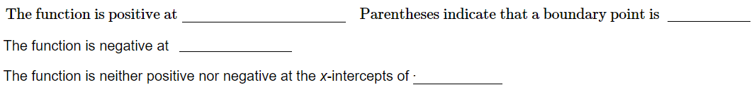

**Try It!**

**3. a.** For what interval(s) is h(x) = 2x + 10 positive?

**b.** For what interval(s) is the function negative?

**Questions**

**p. 4**

**Questions**

**Where a Function Increases or Decreases**

* The greatest value a function attains is the _____________ of the function
* The least value a function attains is the ________________

**Example 4**

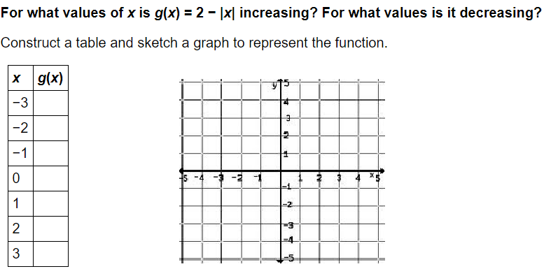

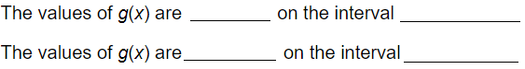

**Try It!**

**4.** For what values of x is each function increasing? For what values of x is it decreasing?

**a.**

**b.**

**Average Rate of Change Over an Interval**

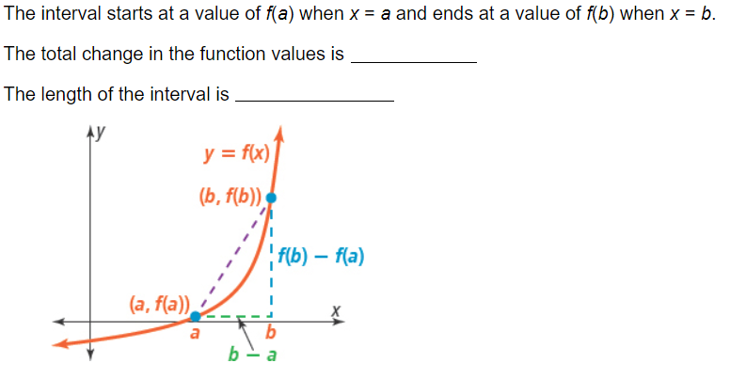



If ( and ( are points on the graph of the linear function y = mx + b, then the average rate of change in the interval [ is m = _____________

**Example 5**

What do the average rates of change over the given intervals indicate about the functions?

|  |  |  |  |
| --- | --- | --- | --- |
|  | **f(x)= 1** | **g(x) = x -1** | **h(x) =** |
|  |  |  |  |
| [-2,0] |  |  |  |
| [0,3] |  |  |  |
| [-2,3] |  |  |  |
|  | f(x) = 1 has the same rate of change, 0, over every interval [a,b]. This means it is a ______________ function. | g(x) = -1 has a constant rate of change, 1/2, over every interval [a, b]. This means it is a ____________ function. | h(x) = does not have a constant rate of change over every interval [a,b]. This means it is a _____________ function. |

**Try It!**

**5.** What do the average rates of change of the function y = |x| + 2 over the intervals [-2, 0], [0, 3], and [-2, 3] indicate about the function?

**p. 5**

**Questions**

**p. 6**

**Questions**

**Concept Summary**

|  |  |  |  |  |
| --- | --- | --- | --- | --- |
| **FUNCTION** | ___________  y = x | ____________  y = | _____________  y = |x| | _____________  y = 1 |
| **GRAPH** |  |  |  |  |
| **KEY FEATURES** | Domain:  ________  Range:  _________  Increasing:  __________ | Domain:  __________  Range:  __________  Increasing:  __________  Decreasing:  ___________ | Domain:  ___________  Range:  ___________  Increasing:  ___________  Decreasing:  ___________ | Domain:  ____________  Range:  ____________ |
| **INTERCEPTS** | X-intercept:  x = ______  Y-intercept:  y = _______ | X-intercept:  x = ______  Y-intercept:  y = _______ | X-intercept:  x = ______  Y-intercept:  y = _______ | X-intercept:  x = ______  Y-intercept:  y = _______ |

**Written Summary**

**EQ:** How do graphs and equations reveal information about a relationship between two quantities?