Submitting Assignments on Portal/Focus Gradebook

1. Log in to your focus using R2.D2 and password

2. On the left hand side there are the list of courses. Select the assignment listed under the course.

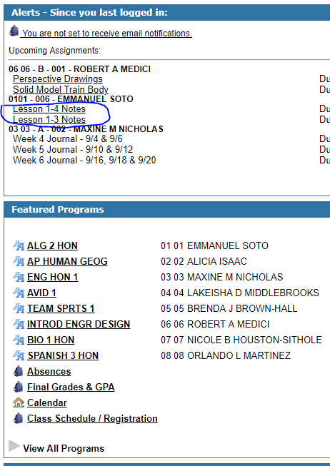

3. Click on the Edit/Upload button for assignments that you are to submit online.

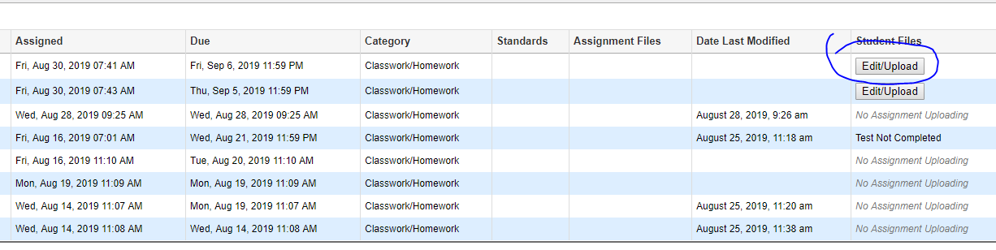

4. Upload any pictures of the notes or other assignment from your phone (or computer) to the assignment. You can submit more than one picture or document for a given assignment.