2.6 & 2.8 Assessment Review

1. What is the number of real solutions?

2. What is the number of real solutions?

3. What is the number of real solutions?

4. 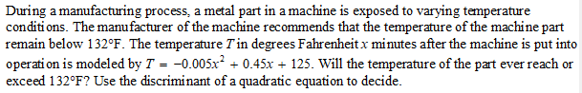

5. Solve using QF:

6. Solve using QF:

7. Solve using QF:

8. 

9. Solve:

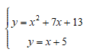

10.

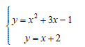

11.

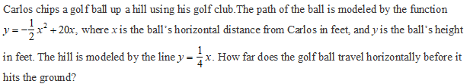

12. Use Graphing to find number of solutions:

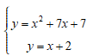

13. Use Graphing to find number of solutions:

