Lesson 2.8 Check Your Understanding Key

**Learning Goal # 1**: Determine the number of real solutions for a linear-quadratic system by graphing

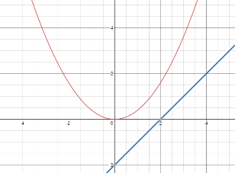

1. No solutions

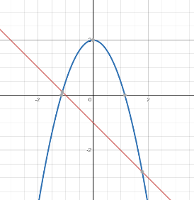

1. Two solutions

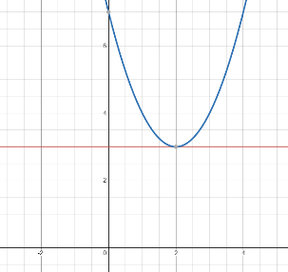

**Learning Goal # 2:** Solve a linear-quadratic system algebraically

1. (5.83, 132.76), (-1.83, -12.76)
2. No solutions
3. (3, 15)

**Learning Goal # 3:** Solve a linear-quadratic system using technology

1. X -0.61, 2.45
2. X = 2

**Apply the concepts: Solve linear-quadratic systems given a real-world context**

1. 25.6 ft
2. Boulder will be 500 meters above the ground when it travels the hillside, having traveled 1,500 meters horizontally.

