Standard Form | Transformational / Vertex Form | Factored Form
Formula:  $$f\left(x\right)=ax^{2}+bx+c$$ | Formula:  $$f\left(x\right)=a{\left(x-h\right)}^{2}+k$$ | Formula:  $$f\left(x\right)=a(x-p)(x-q)$$
Process for rewriting: | Process for rewriting: | Process for rewriting:
Parameters: | Parameters: | Parameters:
Helpful for finding:  x-intercept(s) y-intercept  vertex concavity  vertical stretch/squish | Helpful for finding:  x-intercept(s) y-intercept  vertex concavity  vertical stretch/squish | Helpful for finding:  x-intercept(s) y-intercept  vertex concavity  vertical stretch/squish
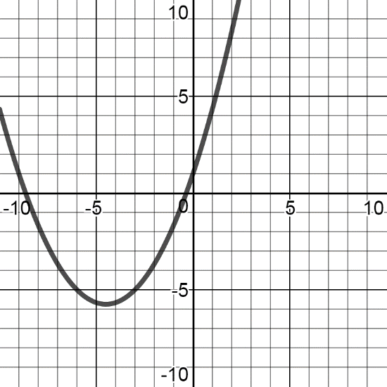  Example:  $$\frac{1}{3}x^{2}+3x+1$$ | Example:  $$-2{\left(x-4\right)}^{2}+5$$  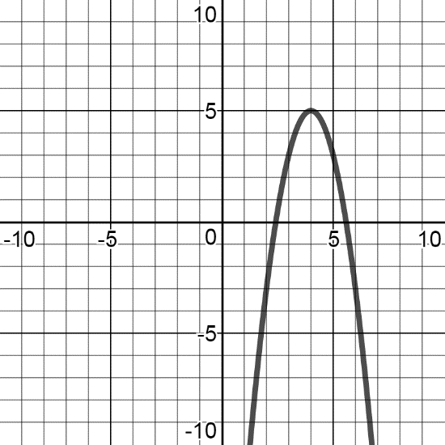 | 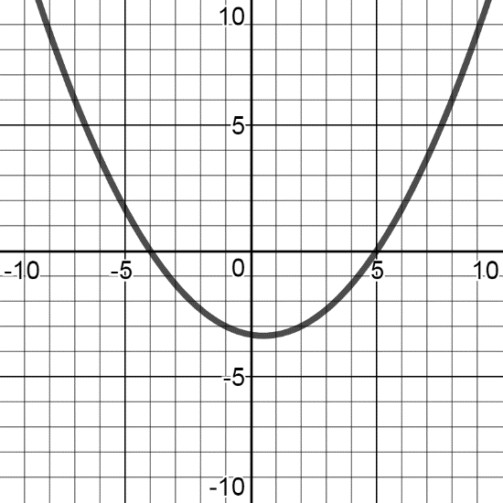  Example:  $$\frac{1}{6}(x-5)(x+4)$$

