**Using the Class Website and Clever (Algebra II Honors)**

Accessing the Class website (2 options)

1) You can use the following url: **bit.ly/bchsmath OR**

2) You can go to Clever.com, click on Mr. Soto’s resources, then click on Class website icon.

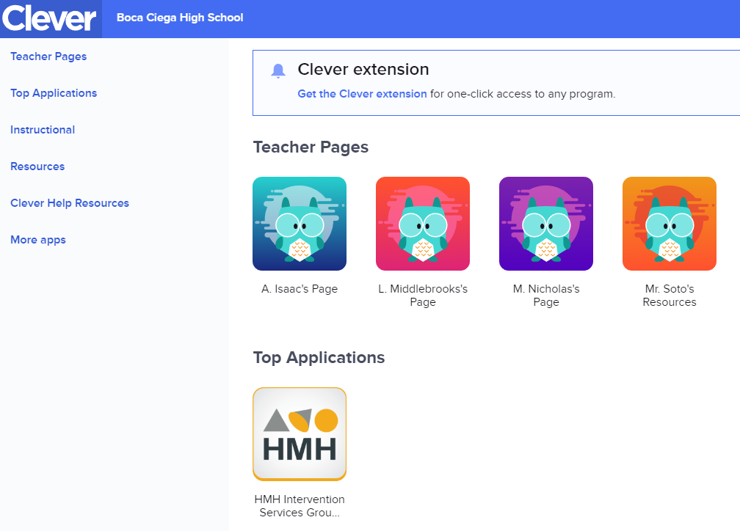



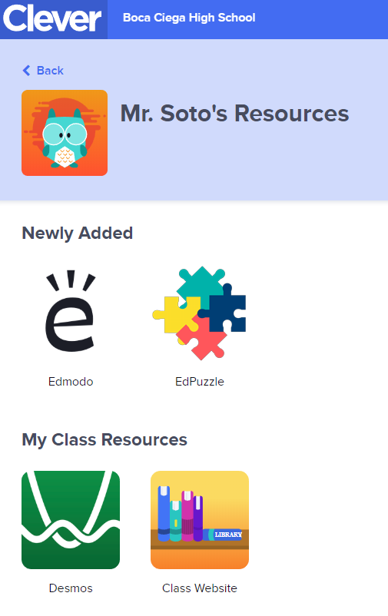



Accessing lesson videos, ebook pdf pages, solutions to exercises, other documents:

1) Go to the class website: bit.ly/bchsmath

2) You will be taken to the homepage. Click on Algebra II Honors on the top right-hand corner

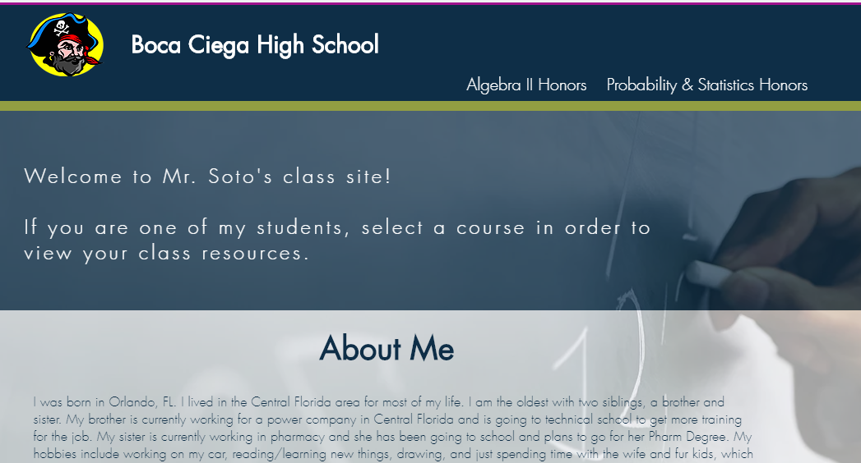



3) Click on your current semester and the unit for the lesson you are working on (for now, we are on Semester 1 working on Unit 1.

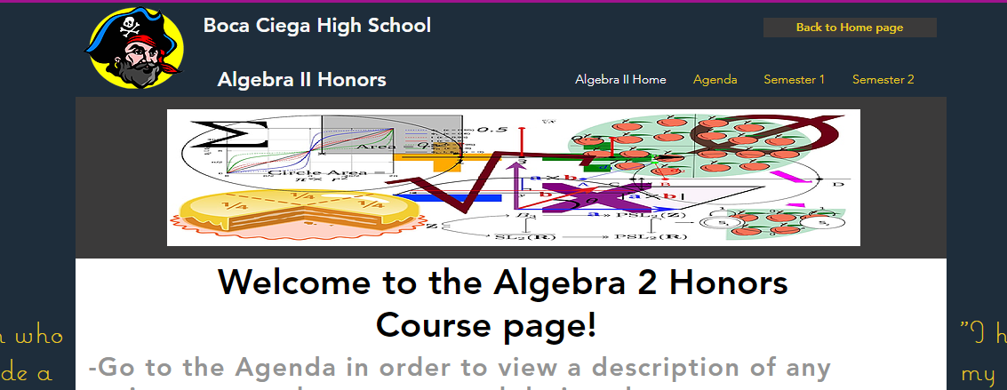



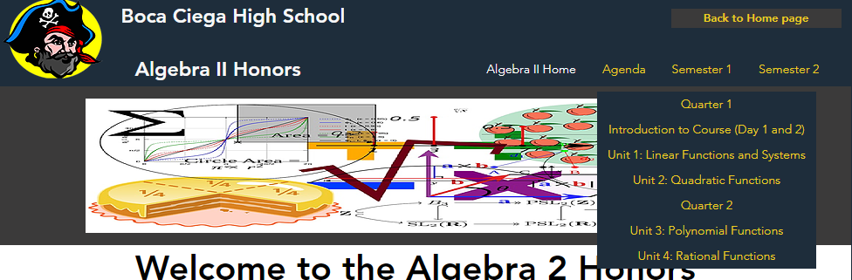



4) Click on the lesson you are working on

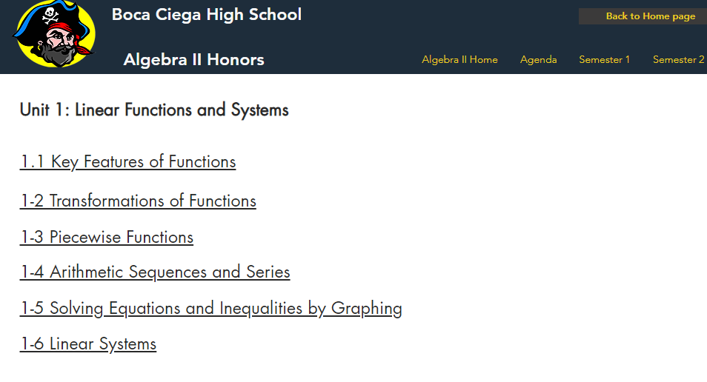



5) You will be taken to a webpage with a video and documents underneath. These documents include the **pdf pages for the Ebook, solutions to most textbook problems, activities/handouts that were passed out in class, etc.**



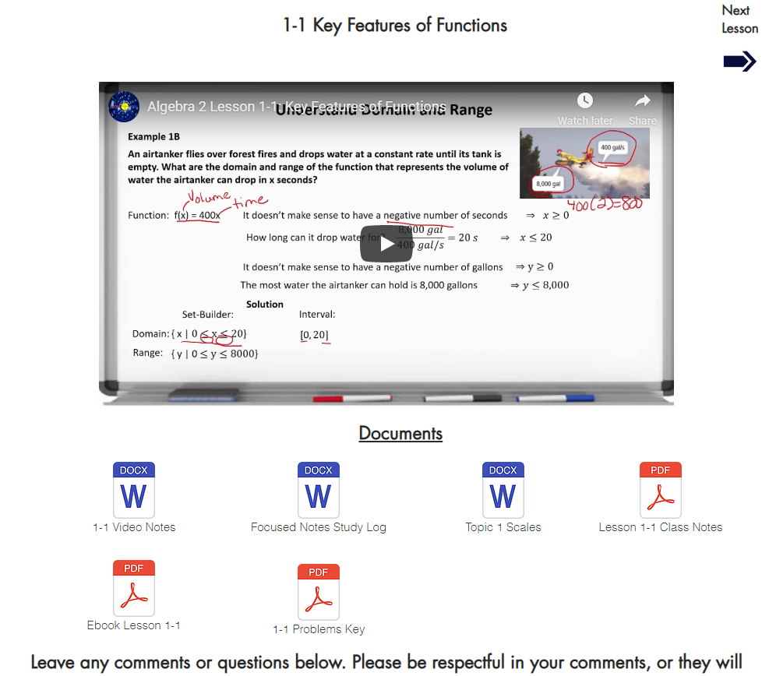



How to find out what you missed in class:

1) Go to classroom website: bit.ly/bchsmath

2) Click on Algebra II Honors



3) Click on Agenda

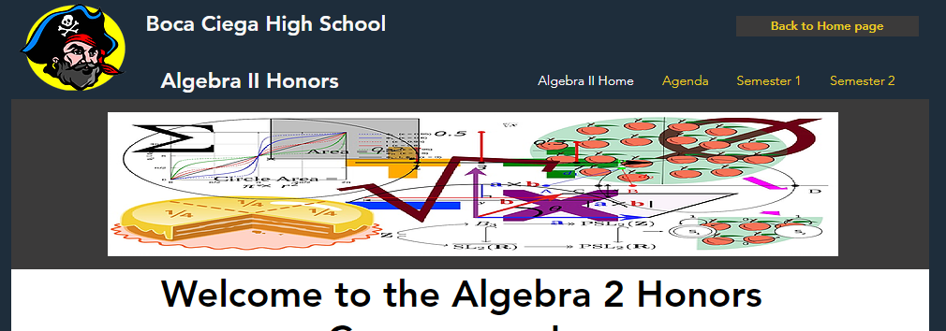



4) Click on the date you are interested in the calendar to pull up more detail on activities done in class as well as any assigned homework problems, etc.

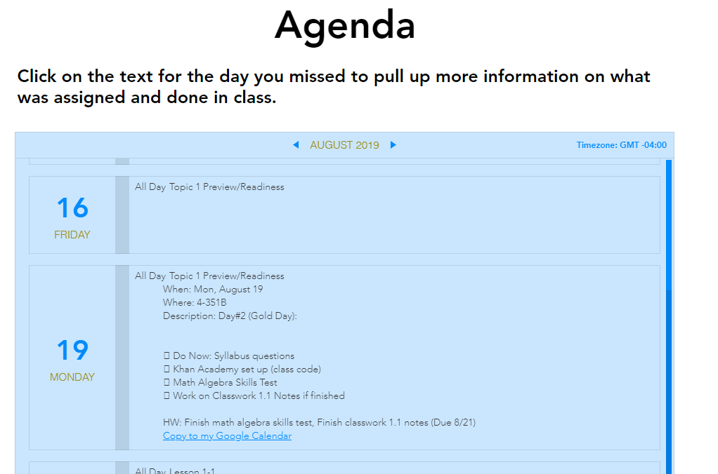



How to access your assignments on Pearson website:

1) Log on to your clever.com account

2) Click on Pearson Easy Bridge

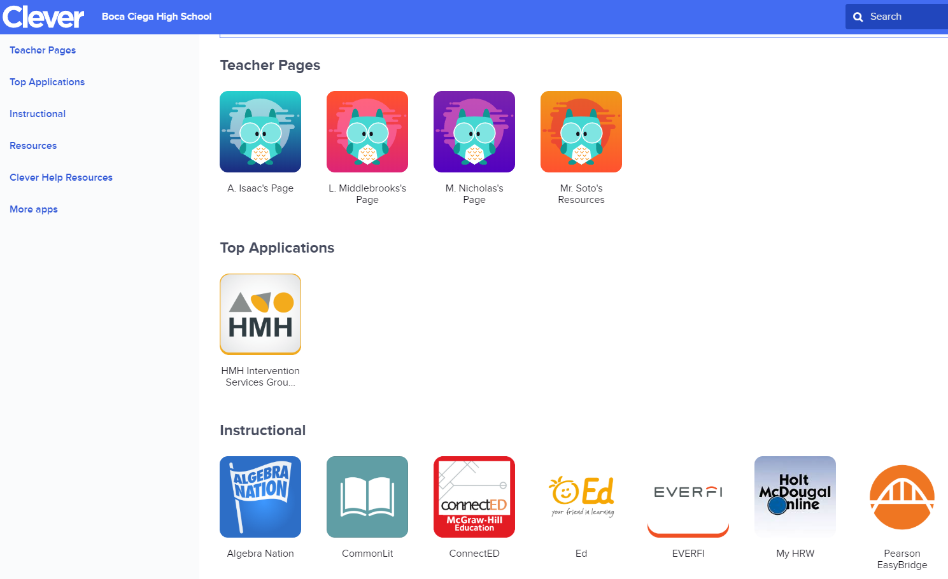



3) Click on Envision Florida Algebra 2 2020

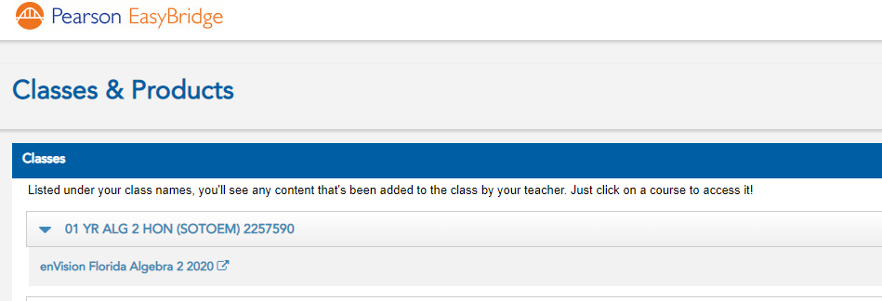



4) **Textbook** will be on the left side and **assignments** will be in the middle



