**Name: Date:**

**Topic: Solving Rational Equations (Class Notes)**

**Essential Question:**

Questions/Key Ideas Notes/Problems/Work

Solving Rational Equations:

1. Find the LCD of all fractions involved.
2. If present, add or subtract fractions on each side.
3. Multiply both sides by the denominator.
4. Simplify and solve for x.
5. Check each solution by plugging into the original equation.

> You must check solutions because it is possible that they are ___________________ solutions

> These solutions involve getting a _______ in the denominator, which makes the fraction undefined!





Questions/Key Ideas Notes/Problems/Work



Try It!

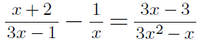

Summary (Address EQ):